

**Polling District and Polling Place Review 2025**

**Arthur’s Hill Ward**

**Parliamentary Constituency:** Central and West

**(Proposed) Polling Districts:** A01, A02, A03, A04

The Local Government Boundary Commission for England are an independent body accountable to Parliament. They are responsible for reviewing councils to make sure their patterns of internal wards are fair and sensible. Their reviews include at least two rounds of public consultation before they make recommendations for change.

The final recommendations were published on 7 January 2025, and the new arrangements apply to local elections from 2026.

As a result of changes to ward boundaries the Acting Returning Officer (ARO) is conducting a review of polling districts and polling places to ensure that they are suitable for the new ward boundaries.

For more information on the local government boundary review visit: <https://www.lgbce.org.uk/all-reviews/newcastle-upon-tyne>

This document provides details of the review, along with the initial recommendations and comments of the Acting Returning Officer (ARO). Also, the election rules require the ARO to decide how many polling stations are required for each polling station and the ARO must allocate electors to the polling stations in such manner as they think most convenient.

These recommendations will be open to all residents, stakeholders, and any interested parties. We shall be seeking representations from local disability groups on the accessibility and suitability of polling places. Any comments should be addressed in the first instance to pollingplaces@newcastle.gov.uk where they will be collated on behalf of the (Acting) Returning Officer.

We considered the following factors:

* **Identifying new polling places:** We will look for new polling places in areas where the existing provision is unsuitable or unavailable.
* **Feedback:** We will consider feedback received following recent elections, consultation from members of the public, elected members, and other stakeholders.
* **Accessibility:** We will try to ensure that every polling place is accessible to electors with disabilities.
* **Facilities**: We will make sure that all electors have such reasonable facilities for voting as are practicable in the circumstances.
* **Elector numbers:** We will try to comply with the Electoral Commission guidance on the maximum number of electors that should be allocated to a polling station which should not exceed 2,250.
* **Future housing developments**: We will consider the impact of proposed housing developments on polling station electorates.

**(Current) Arthur’s Hill Ward**

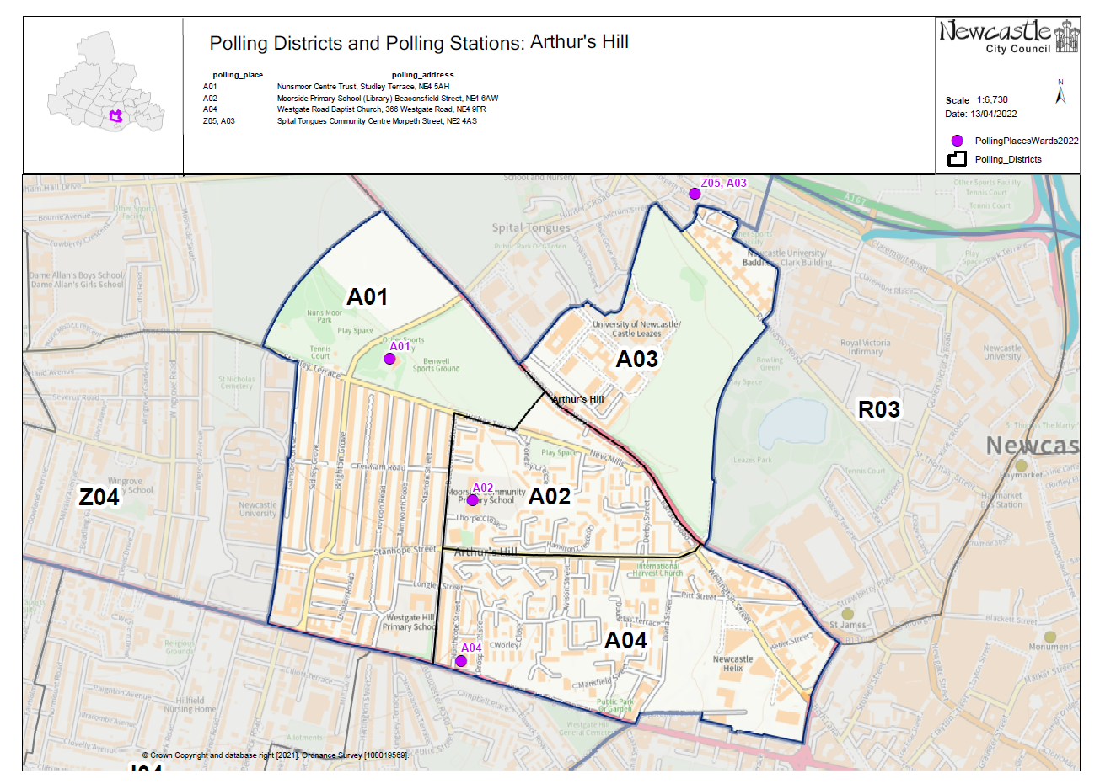This map shows the current ward and polling district boundaries and the polling places.

**(New) Arthur’s Hill Ward**

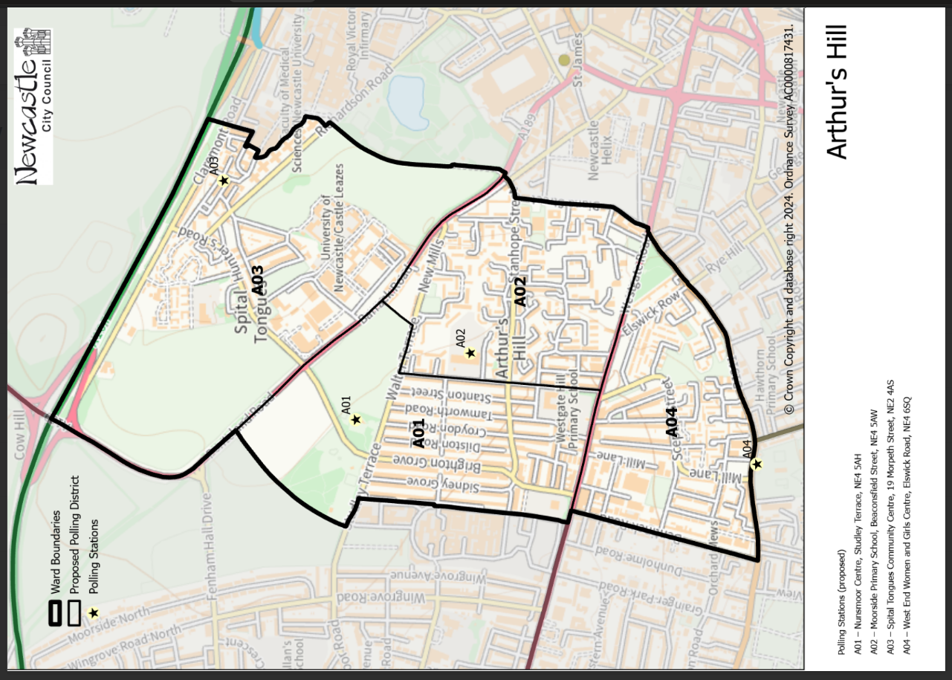This map shows the new ward and the proposed polling districts and the proposed polling places.

* **A01**

Nunsmoor Centre, Studley Terrace, NE4 5AH

* **A02**

Moorside Primary School, Beaconsfield Street, NE4 5AW

* **A03**

Spital Tongues Community Centre, 19 Morpeth Street, NE2 4AS

* **A04**

West End Women and Girls Centre, Elswick Road, NE4 6SQ

**Arthur’s Hill Ward**

**Polling District A01**

|  |  |  |
| --- | --- | --- |
| **Current Polling District** | | **Current Polling Place** |
| A01 (full) | | Nunsmoor Centre Trust, Studley Terrace, NE4 5AH |
|  | | |
| **Proposed Polling District** | **Predicted Polling Station Electorate** | **Proposed Polling Place** |
| A01 | 2093 | Nunsmoor Centre Trust, Studley Terrace, NE4 5AH |
|  | | |
| **Considerations and Proposals** | | |
| No change to the polling district boundary.  No change to the polling place. | | |
|  | | |
| **Preliminary Consultation – Elected Members comments and feedback** | | |
| No comments received. | | |

**Arthur’s Hill Ward**

**Polling District A02**

|  |  |  |
| --- | --- | --- |
| **Current Polling District** | | **Current Polling Place** |
| A02 (full)  A04* (part of) | | Moorside Primary School, Beaconsfield Street, NE4 5AW  Westgate Baptist Church, 366 Westgate Road, NE4 6NX |
|  | | |
| **Proposed Polling District** | **Predicted Polling Station Electorate** | **Proposed Polling Place** |
| A02 | 1922 | Moorside Primary School, Beaconsfield Street, NE4 5AW |
|  | | |
| **Considerations and Proposals** | | |
| The current A02 polling district is merged with part of A04 to create the proposed A02 polling district.  The current A02/A04 boundary line goes along Stanhope Street to separate the two districts. The proposal is to remove this boundary. The new ward boundary has changed so that the new eastern boundary line is down Diana Street.  Both Moorside Primary School and Westgate Baptist Church fall within the proposed polling district boundary. The proposal is to continue to use Moorside Primary School to serve the electors in this polling district.  Whilst Westgate Baptist Church is a suitable premises, it is felt that Moorside Primary School is in a better location to serve the full district. | | |
|  | | |
| **Preliminary Consultation – Elected Members comments and feedback** | | |
| No comments received. | | |

|  |  |  |
| --- | --- | --- |
| **Current Polling District** | | **Current Polling Place** |
| A03* (part of)  Z05* (part of) | | Spital Tongues Community Centre, 19 Morpeth Street, NE2 4AS  Spital Tongues Community Centre, 19 Morpeth Street, NE2 4AS |
|  | | |
| **Proposed Polling District** | **Predicted Polling Station Electorate** | **Proposed Polling Place** |
| A03 | 789 | Spital Tongues Community Centre, 19 Morpeth Street, NE2 4AS |
|  | | |
| **Considerations and Proposals** | | |
| The majority of the current A03 would be merged with a large part of the current Z05 to create the proposed A03 polling district.  The west boundary line of the current A03 is extended into the current Z05. The proposed A03 district boundary would continue along Ponteland Road, Grandstand Road, and would end as it met the northern boundary line along Claremont Road. A very small section of the current A03 is now part of Monument ward.  No change to the polling place. | | |
|  | | |
| **Preliminary Consultation – Elected Members comments and feedback** | | |
| No comments received. | | |

**Arthur’s Hill Ward**

**Polling District A03**

**Arthurs Hill Ward**

**Polling District A04**

|  |  |  |
| --- | --- | --- |
| **Current Polling District** | | **Current Polling Place** |
| J03* (part of)  J04* (part of) | | West End Women and Girls Centre, Stephenson Building, 173 Elswick Road, NE4 6SQ  Newcastle Dance Centre, 36-38 Grainger Park Road, NE4 8RY |
|  | | |
| **Proposed Polling District** | **Predicted Polling Station Electorate** | **Proposed Polling Place** |
| A04 | 1238 | West End Women and Girls Centre, Elswick Road, NE4 6SQ |
|  | | |
| **Considerations and Proposals** | | |
| Part of current J03 (formally Elswick ward) is merged with part of current J04 (formally Elswick ward) to create the proposed A04 district.  Newcastle Dance Centre and West End Women and Girls Centre are both outside of the proposed A04 polling district.  An alternative premises within the proposed district, Laidlaw House on Elswick Road, NE4 6SN was considered. It was determined that this premises would not be suitable as it is too small.  The proposal is therefore to continue using West End Women and Girls Centre as a polling place to serve electors of A04. This premises would house two separate polling stations A04 and I02 (Elswick). | | |
|  | | |
| **Preliminary Consultation – Elected Members comments and feedback** | | |
| No comments received. | | |

THIS PAGE IS INTENTIONALLY BLANK